Recipe

Step 1 _____________________________________________________

Step 2 _____________________________________________________

Step 3 ____________________________________________________

Step 4 ____________________________________________________
Guest Check

Table #____________
Food | Price

Total $____________
Menu  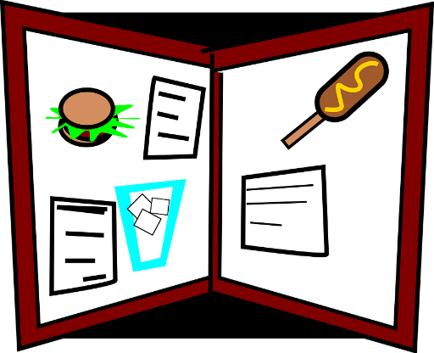 |   Chef
  Customer | Server  
Placemat   | Check  







