Blueprint

I’m Making_____________________________
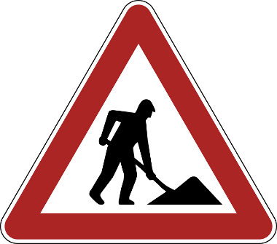
Construction Orders

- _________________________
- _________________________
- _________________________
- _________________________
- _________________________
- _________________________
- _________________________

 | 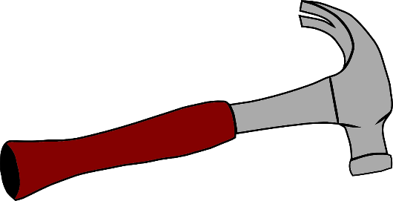  Hammer | 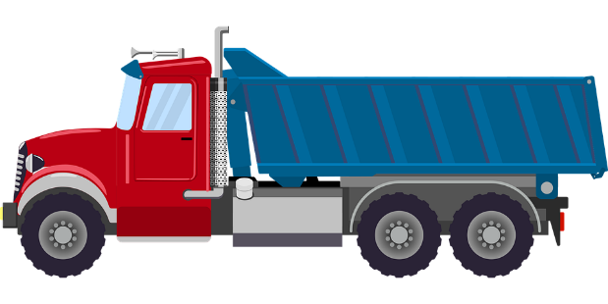  Truck
 | 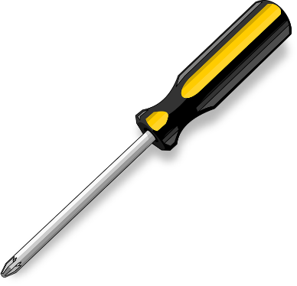  Screwdriver | 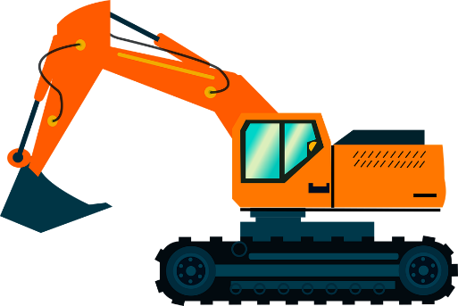  Digger
 | Nail  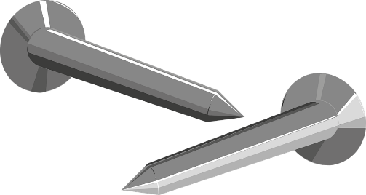 | Crane  

